**Module - 4 Introduction to DBMS**

1. **Introduction to SQL**

**Leb 1 : Create a new database named school_db and a table called students with the following columns: student_id, student_name, age, class, and address.**

CREATE TABLE student( student_id int AUTO_INCREMENT PRIMARY KEY,student_name VARCHAR(60),age int(10),class int(10),address VARCHAR(50));

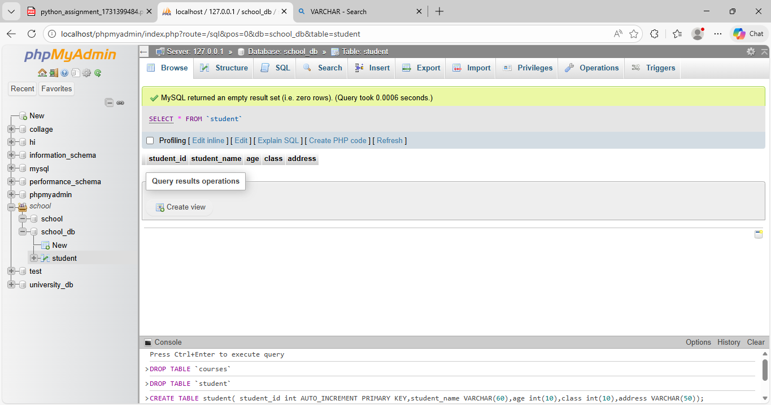

**Lab 2 : Insert five records into the students table and retrieve all records using the SELECT statement.**

INSERT INTO student (student_name,age,class,address)VALUES

("Ketan Goswami",23,12,"Kanbha"),

("Deepak",20,11,"Ahmedabad"),

("Mitansu",19,10,"Nikol"),

("jay",18,12,"Naroda"),

("divyang",19,12," Bapungar");

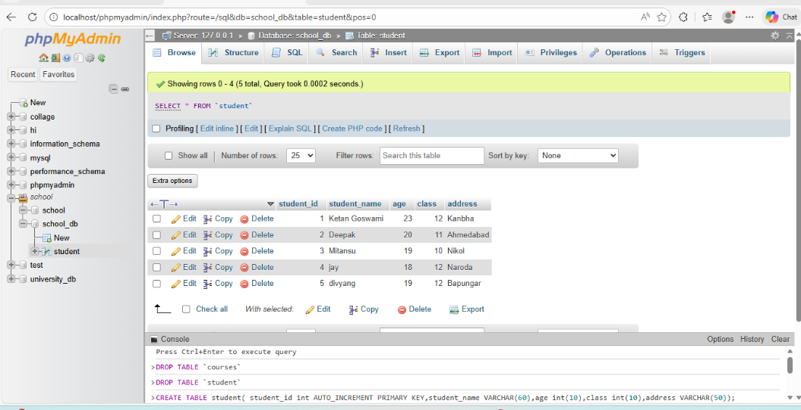

SELECT * FROM student;

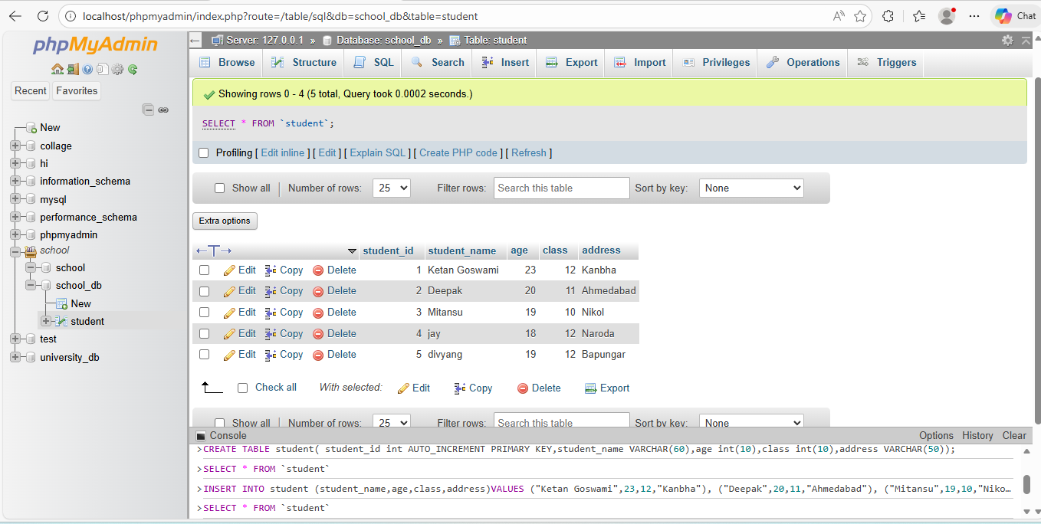

1. **SQL Syntax**

**Lab 1: Write SQL queries to retrieve specific columns (student_name and age) from the students table.**

SELECT student_name,age FROM student;

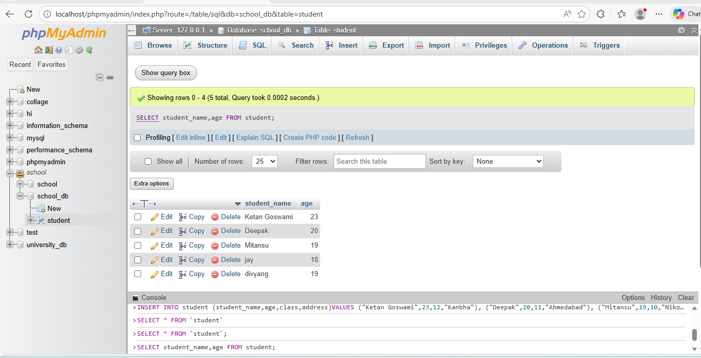

**Lab 2: Write SQL queries to retrieve all students whose age is greater than 10.**

SELECT * FROM student WHERE age>10;

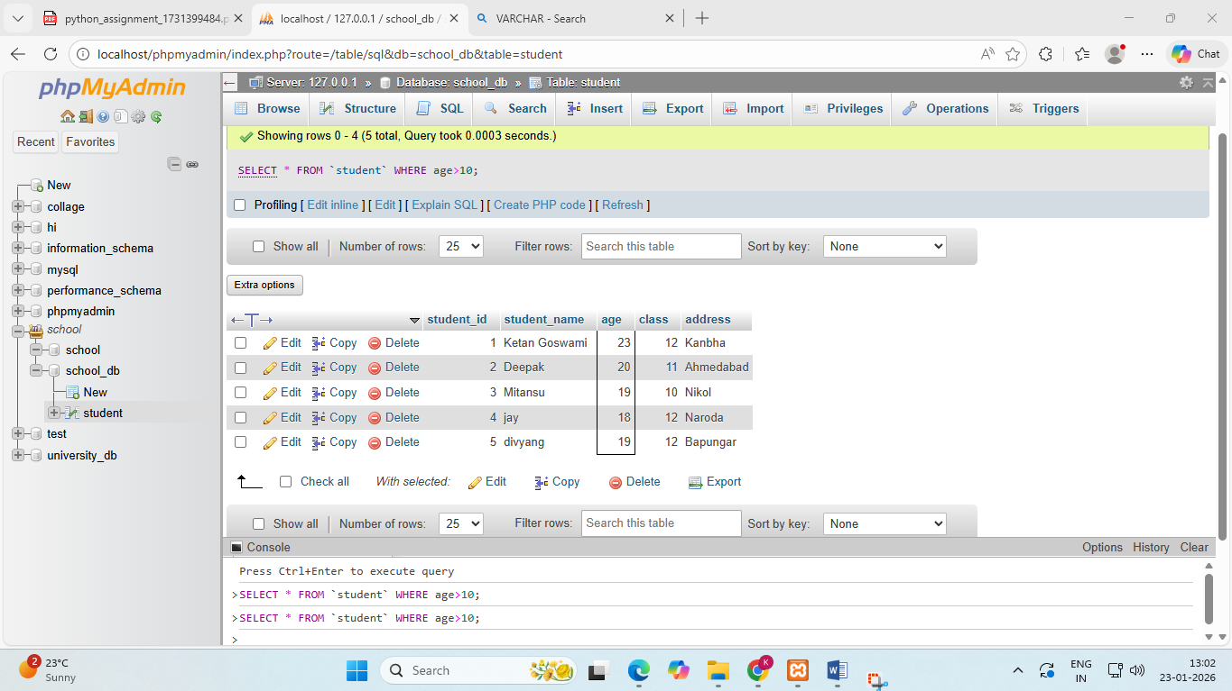

1. **SQL Constraints**

**CREATE TABLE teachers(teacher_id INT PRIMARY KEY AUTO_INCREMENT,teacher_name VARCHAR(50)NOT NULL, subject VARCHAR(50) NOT NULL,email VARCHAR(50) UNIQUE KEY)**

CREATE TABLE teachers(teacher_id INT PRIMARY KEY AUTO_INCREMENT,teacher_name VARCHAR(50)NOT NULL, subject VARCHAR(50) NOT NULL,email VARCHAR(50) UNIQUE KEY);

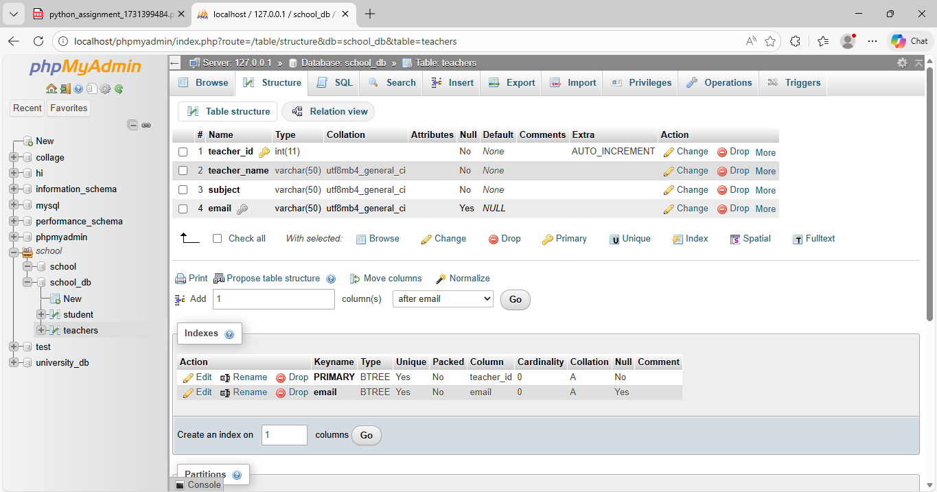

**Lab 2: Implement a FOREIGN KEY constraint to relate the teacher_id from the teachers table with the students table.**

[CREATE](http://localhost/phpmyadmin/url.php?url=https://dev.mysql.com/doc/refman/8.0/en/create-table.html) [TABLE](http://localhost/phpmyadmin/url.php?url=https://dev.mysql.com/doc/refman/8.0/en/create-table.html) student(student_id INT(5) PRIMARY KEY AUTO_INCREMENT,student_name VARCHAR(50),age INT(5),Class int(10),address VARCHAR(50),teacher_id INT(5),FOREIGN KEY(teacher_id) REFERENCES teachers(teachers_id));

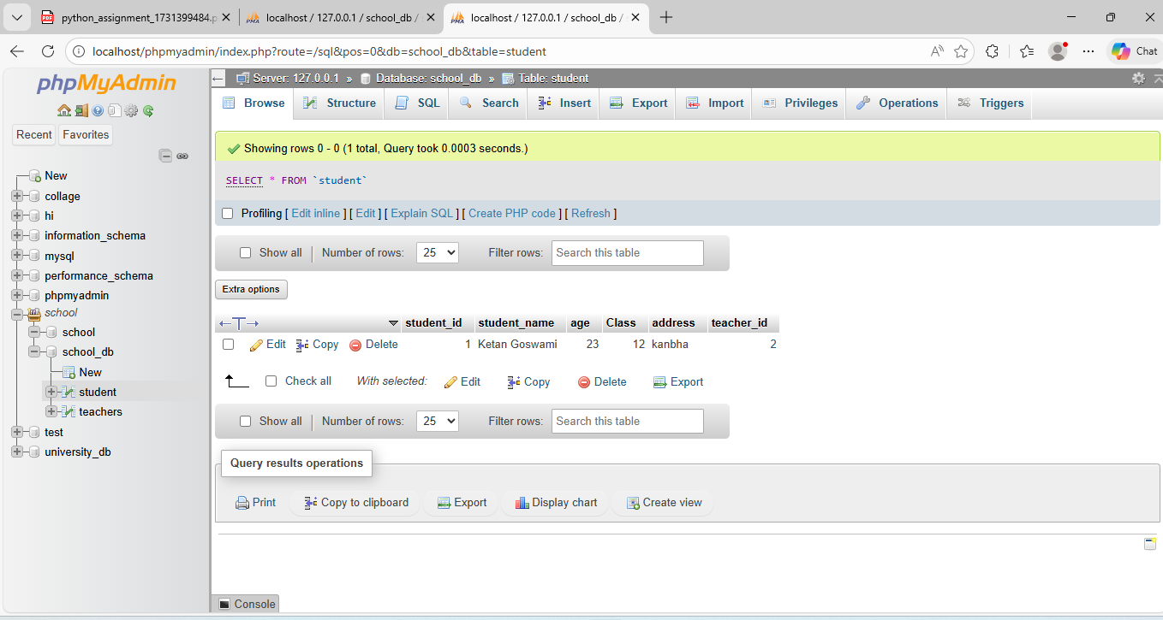

1. **Main SQL Commands and Sub-commands (DDL)**

**Lab 1: Create a table courses with columns: course_id, course_name, and course_credits. Set the course_id as the primary key.**

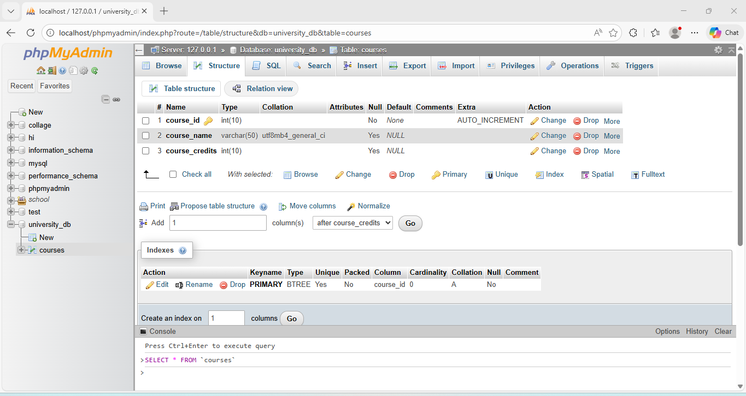

**Lab 2: Use the CREATE command to create a database university_db.**

CREAT DATABASE university_db;

1. **Main SQL Commands and Sub-commands (DDL)**

**Lab 1: Modify the courses table by adding a column course_duration using the ALTER command.**

**ALTER TABLE courses ADD course_duration INT(10);**

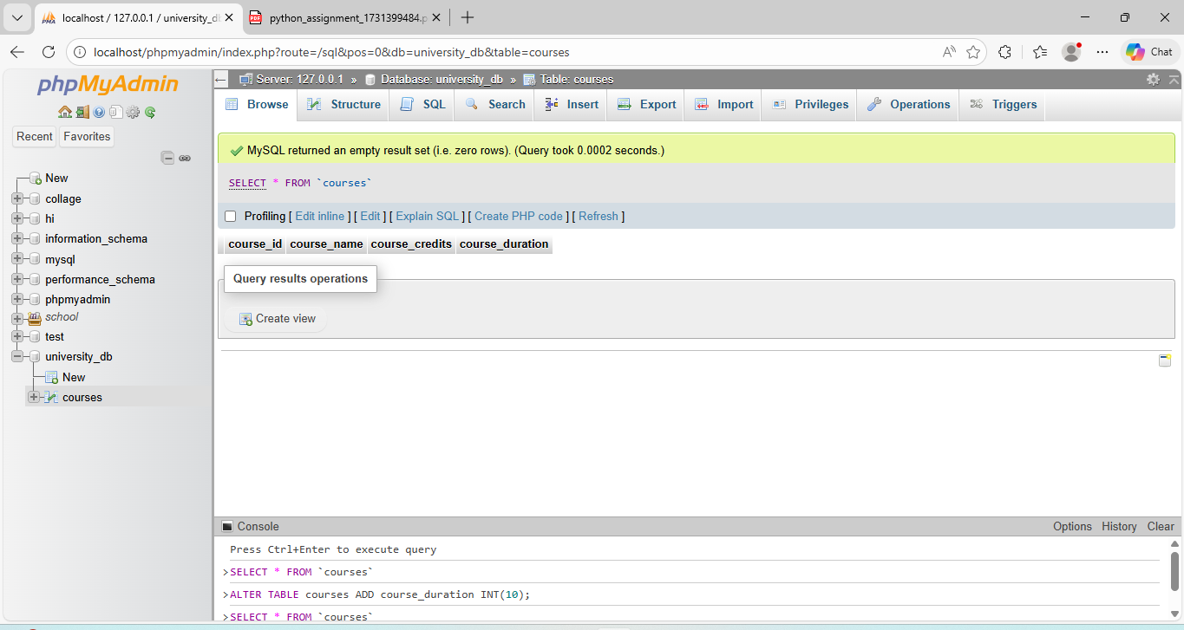

**• Lab 2: Drop the course_credits column from the courses table.**

**ALTER TABLE courses DROP course_credits;**

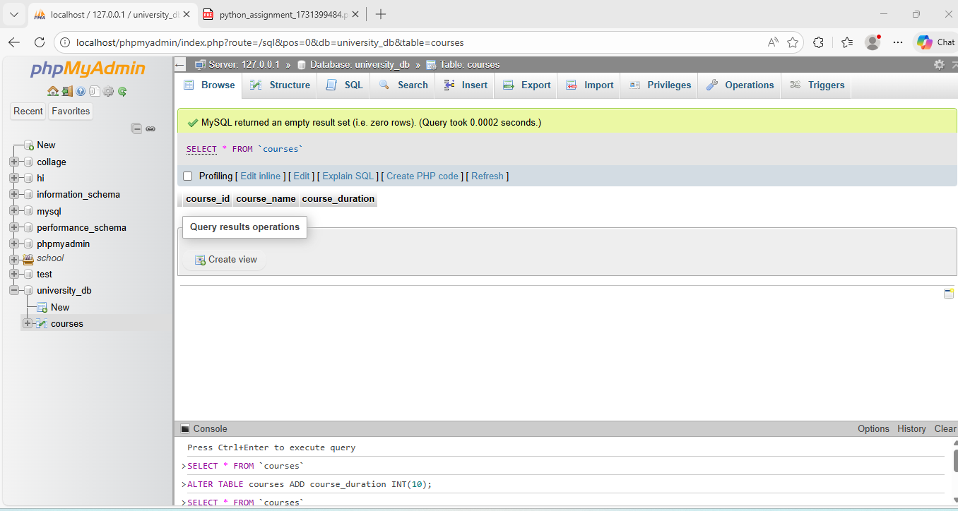

1. **DROP Command**

**Lab 1: Drop the teachers table from the school_db database.**

**DROP TABLE teachers;**

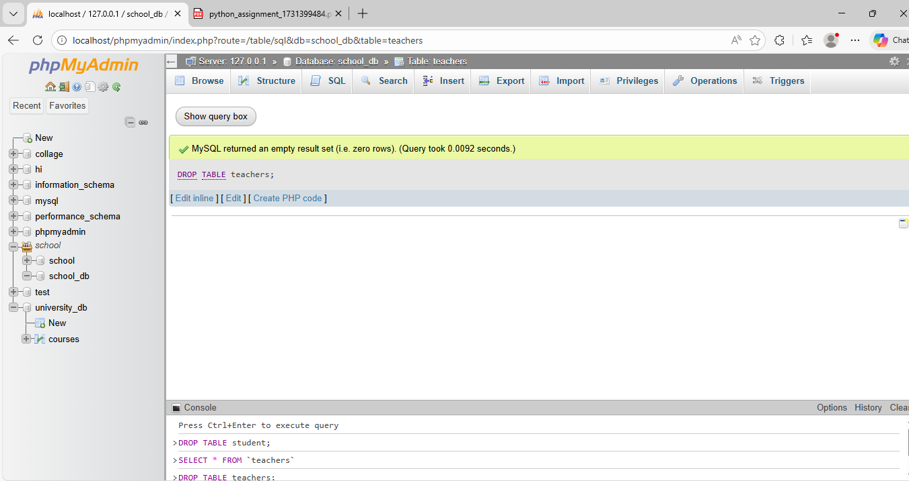

**• Lab 2: Drop the students table from the school_db database and verify that the table has been removed.**

**DROP TABLE studens;**

1. **Data Manipulation Language (DML)**

**Lab 1: Insert three records into the courses table using the INSERT command.**

**INSERT INTO courses(course_name,course_duration)VALUE("Java","3 Month")**

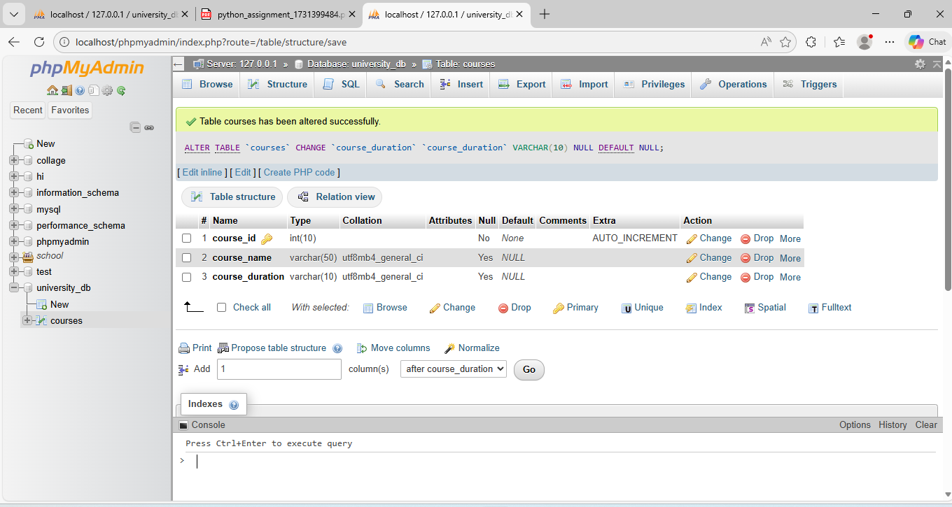

**Lab 2: Update the course duration of a specific course using the UPDATE command.**

**UPDATE courses SET course_name = "Python" WHERE course_id=1;**

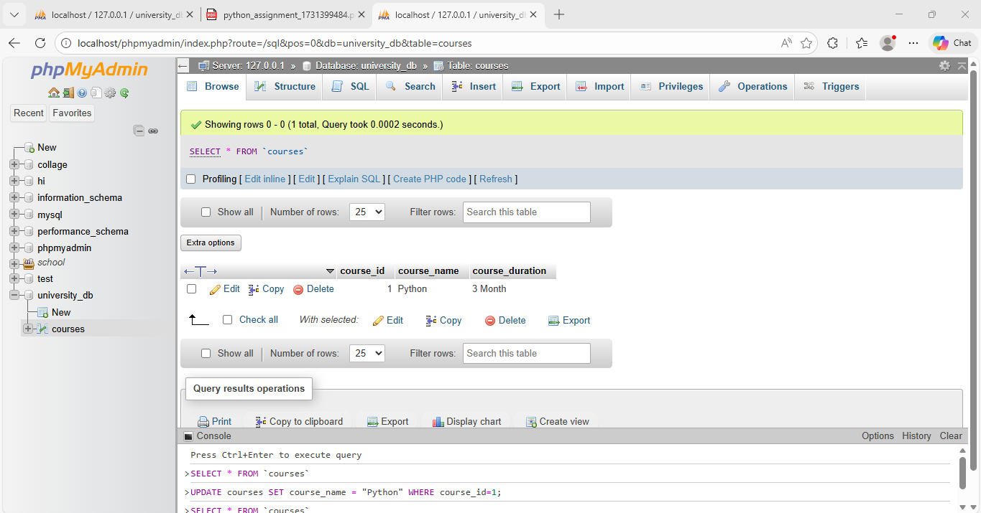

**Lab 3: Delete a course with a specific course_id from the courses table using the DELETE command.**

**DELETE FROM courses WHERE course_id=1;**

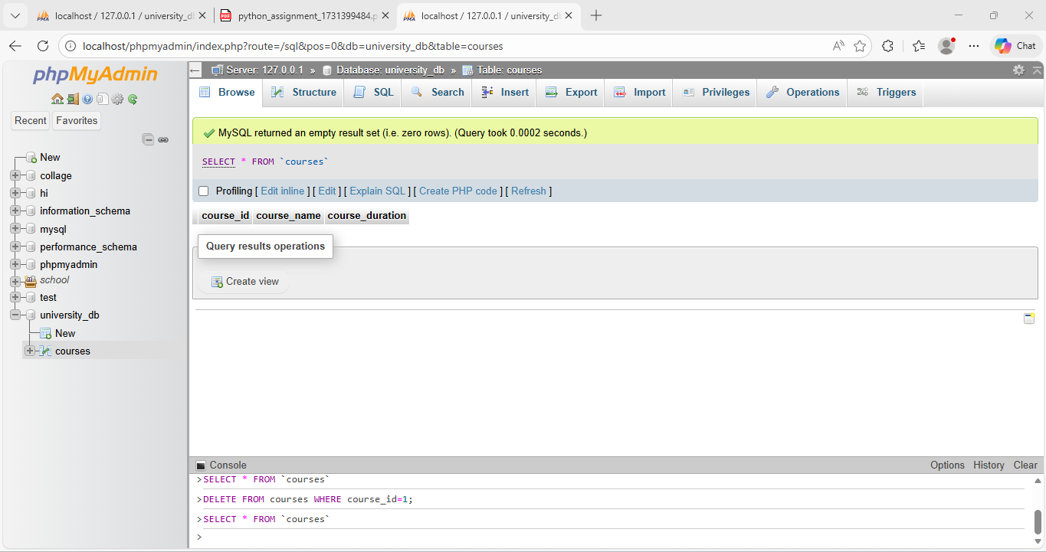

1. **Data Query Language (DQL)**

**Lab 1: Retrieve all courses from the courses table using the SELECT statement.**

**SELECT * FROM courses;**

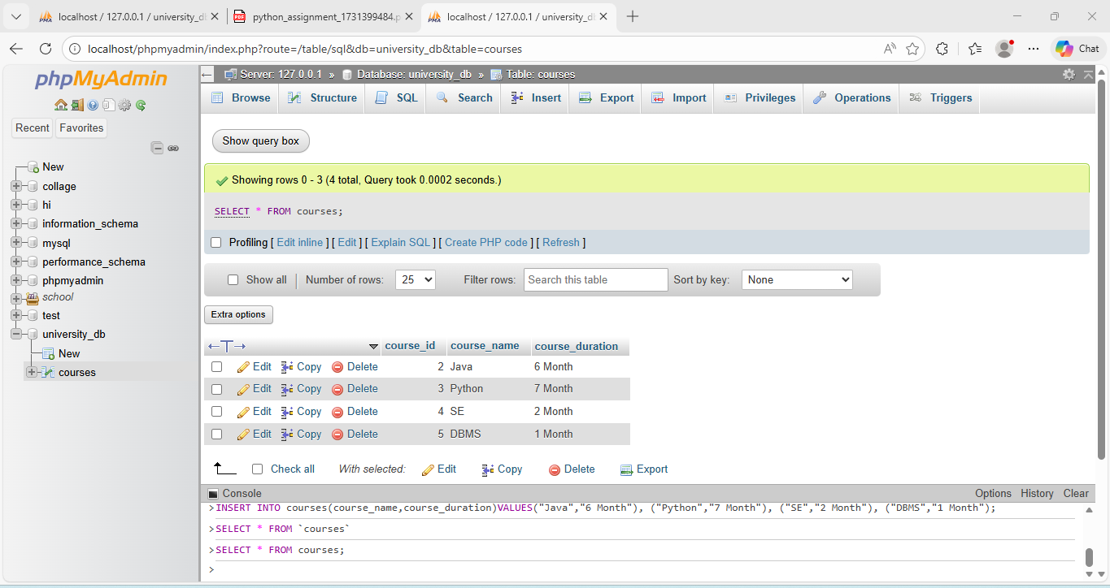

**Lab 2: Sort the courses based on course_duration in descending order using ORDERBY**

**SELECT course_id FROM courses ORDER BY course_id DESC;**

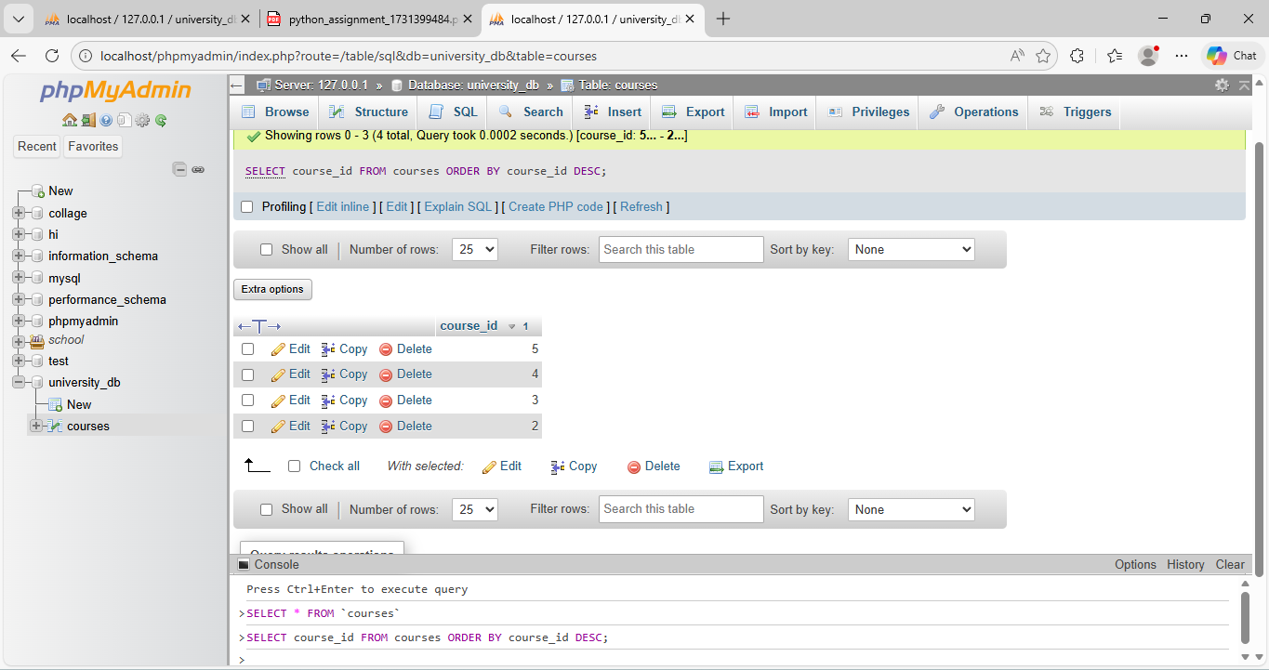

**Lab 3: Limit the results of the SELECT query to show only the top two courses using LIMIT.**

**SELECT * FROM courses ORDER BY course_duration DESC LIMIT 2;**

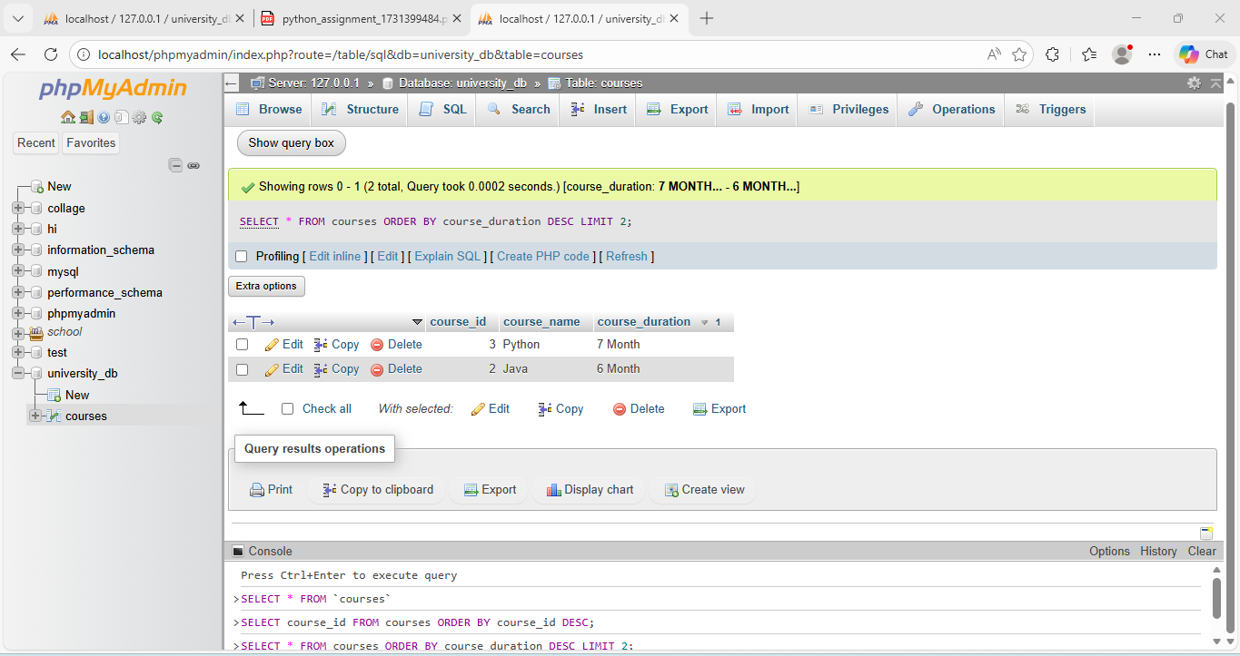

1. **SQL Joins**

**Lab 1: Create two tables: departments and employees. Perform an INNER JOIN to display employees along with their respective departments.**

**CREATE TABLE departments(departments_id INT(10) PRIMARY KEY AUTO_INCREMENT,departments_name VARCHAR(50));**

**INSERT INTO departments(departments_name)VALUES("IT"),("HR"),**

**("Account");**

**CREATE TABLE employees (employees_id INT(10) PRIMARY KEY AUTO_INCREMENT,employees_Name VARCHAR(50),departments_id INT(10),**

**FOREIGN KEY(departments_id) REFERENCES departments(departments_id));**

**INSERT INTO employees (employees_Name,departments_id)**

**VALUES ("Ketan",1),("Bhavesh",1),("Devash",2),("Meghdeep",3);**

**SELECT e.employees_id, e.employees_Name, d.departments_name FROM employees e INNER JOIN departments d ON e.departments_id = d.departments_id;**

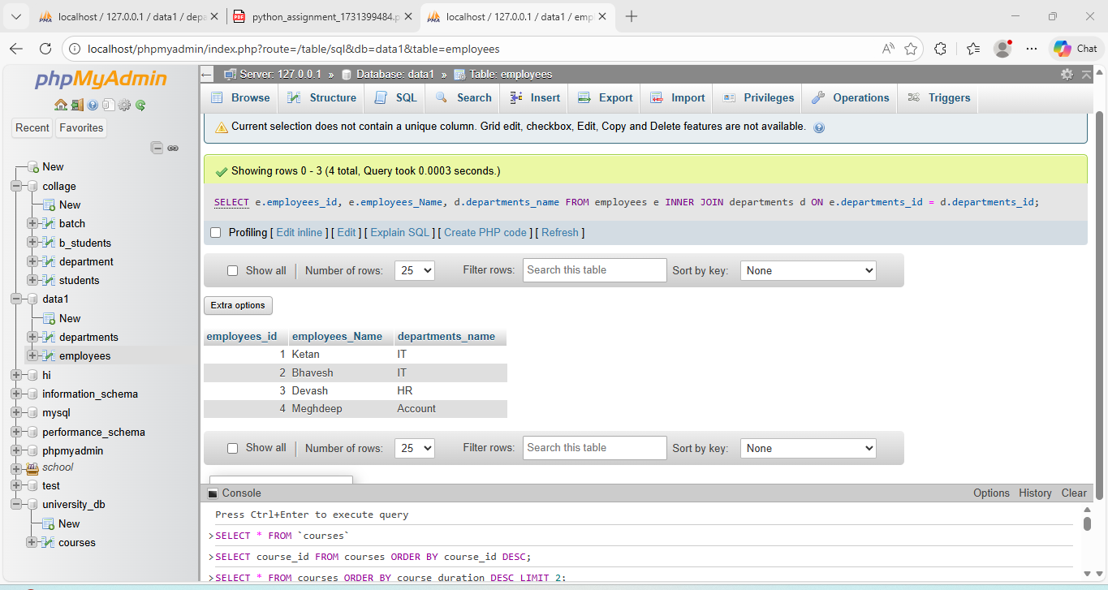

**• Lab 2: Use a LEFT JOIN to show all departments, even those without employees.**

**SELECT d.departments_id, d.departments_name, e.employees_id, e.employees_Name FROM departments d LEFT JOIN employees e ON d.departments_id = e.departments_id;**

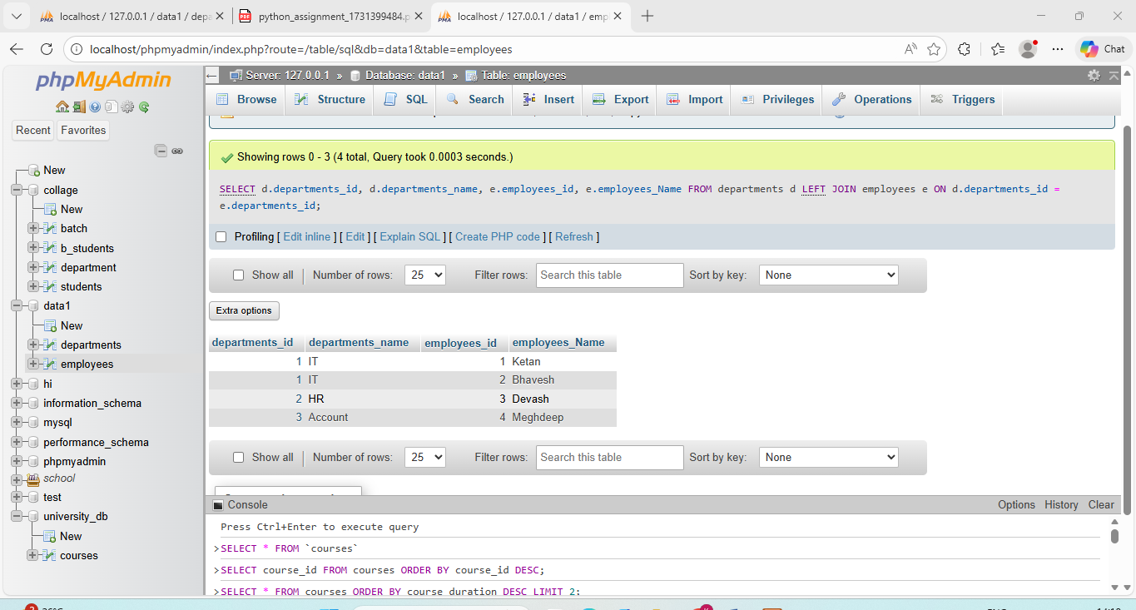

1. **SQL Group By**

**Lab 1: Group employees by department and count the number of employees in each department using GROUP BY.**

**SELECT d.departments_name, COUNT(e.employees_id) AS employee_count FROM departments d LEFT JOIN employees e ON d.departments_id = e.departments_id GROUP BY d.departments_name;**

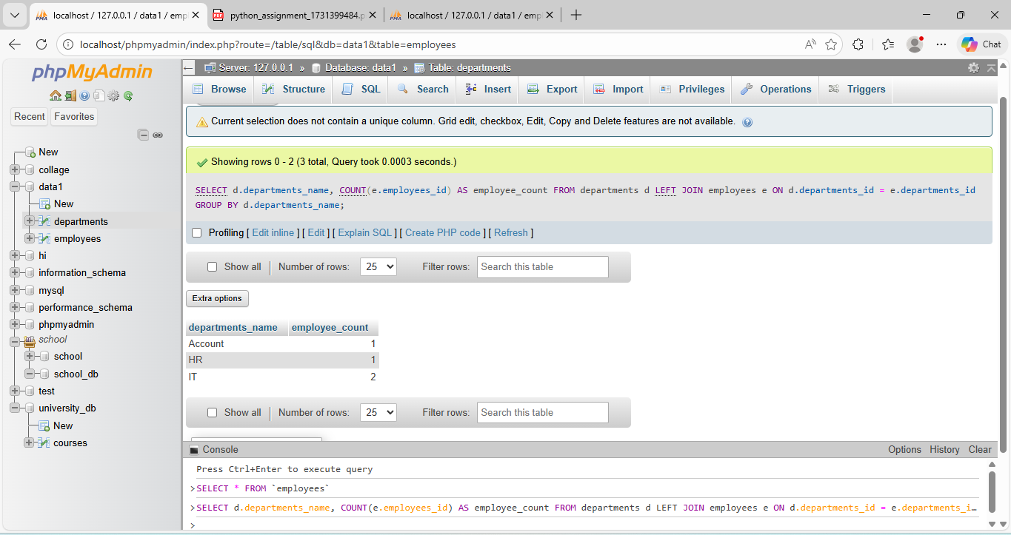

**Lab 2: Use the AVG aggregate function to find the average salary of employees in each**

**department.**

**SELECT d.departments_name, AVG(e.salary) AS average_salary FROM departments d LEFT JOIN employees e ON d.departments_id = e.departments_id GROUP BY d.departments_name;**

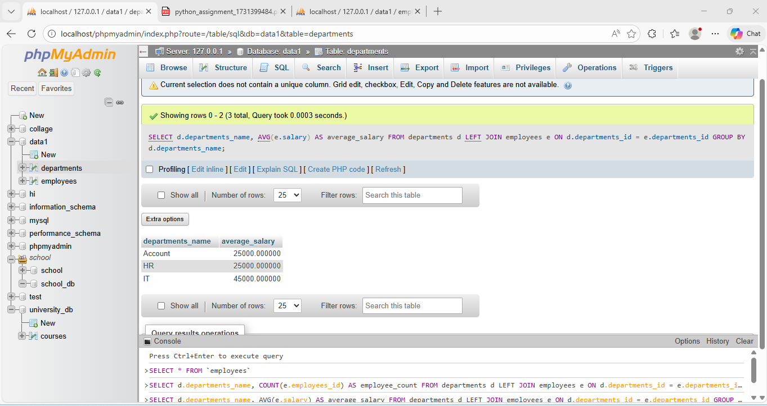

1. **SQL Stored Procedure**

**Lab 1: Write a stored procedure to retrieve all employees from the employees table based on department.**

**DELIMITER //**

**CREATE PROCEDURE det_emp_data()**

**BEGIN**

**SELECT e.*,d.departments_name**

**FROM employees e**

**JOIN departments d**

**ON d.departments_id = e.departments_id;**

**END //**

**DELIMITER ;**

**CALL det_emp_data();**

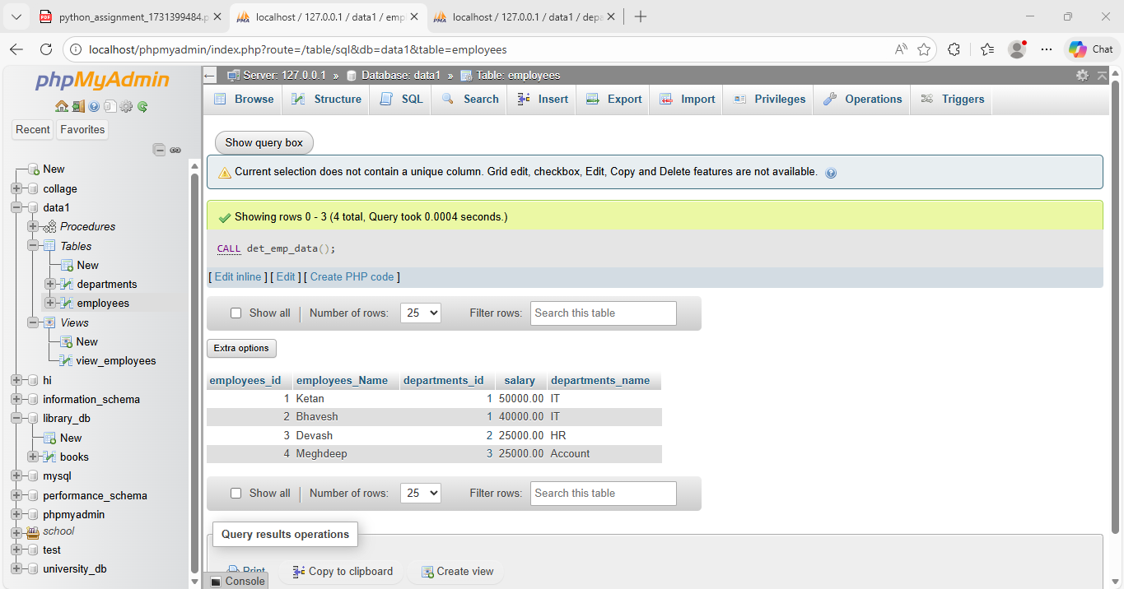

**Lab 2: Write a stored procedure that accepts course_id as input and returns the course details.**

**DELIMITER //**

**CREATE PROCEDURE get_course_details (**

**IN p_course_id INT**

**)**

**BEGIN**

**SELECT \***

**FROM courses**

**WHERE course_id = p_course_id;**

**END //**

**DELIMITER ;**

**CALL get_course_details(2);**

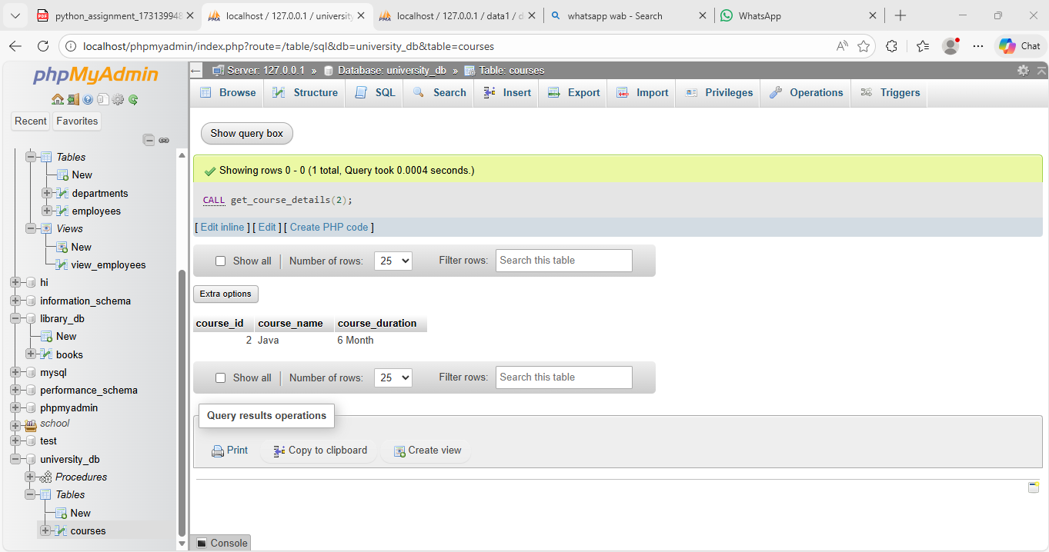

1. **SQL View**

**Lab 1: Create a view to show all employees along with their department names.**

**CREATE VIEW view_employees AS**

**SELECT**

**d.departments_id,**

**d.departments_name,**

**e.employees_id,**

**e.employees_Name**

**FROM departments d**

**LEFT JOIN employees e**

**ON d.departments_id = e.departments_id;**

**Call:**

**SELECT * FROM view_employees;**

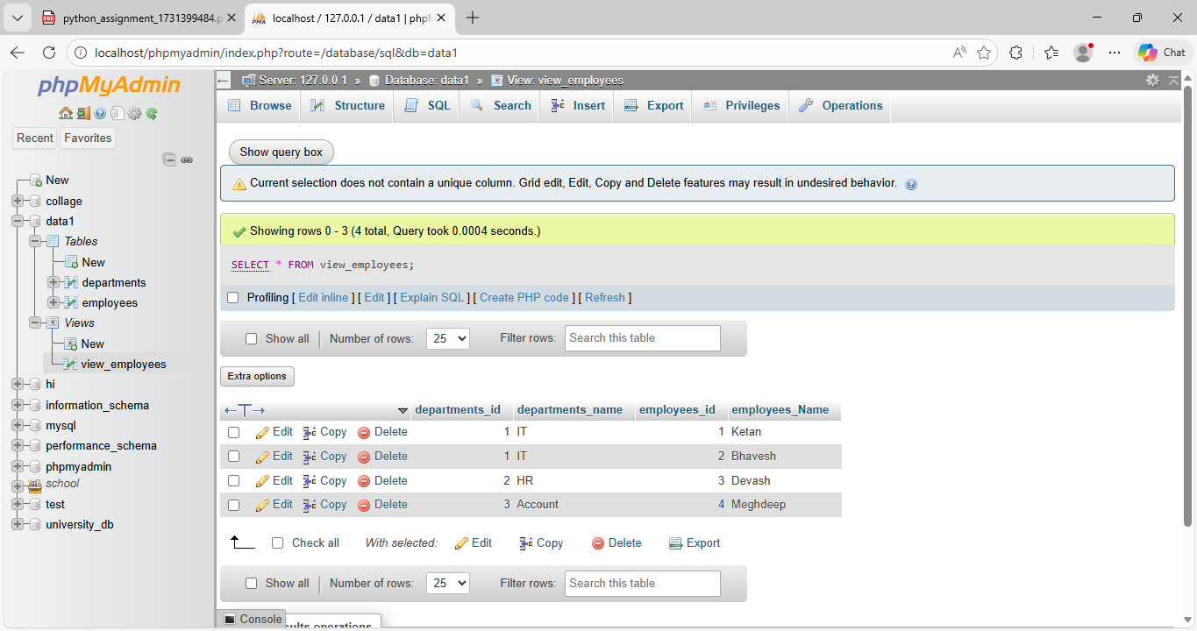

**Lab 2: Modify the view to exclude employees whose salaries are below $50,000.**

**CREATE OR REPLACE VIEW view_employees AS**

**SELECT**

**d.departments_id,**

**d.departments_name,**

**e.employees_id,**

**e.employees_Name,**

**e.salary**

**FROM departments d**

**LEFT JOIN employees e**

**ON d.departments_id = e.departments_id**

**WHERE e.salary >= 50000;**

**Call:**

**SELECT * FROM view_employees;**

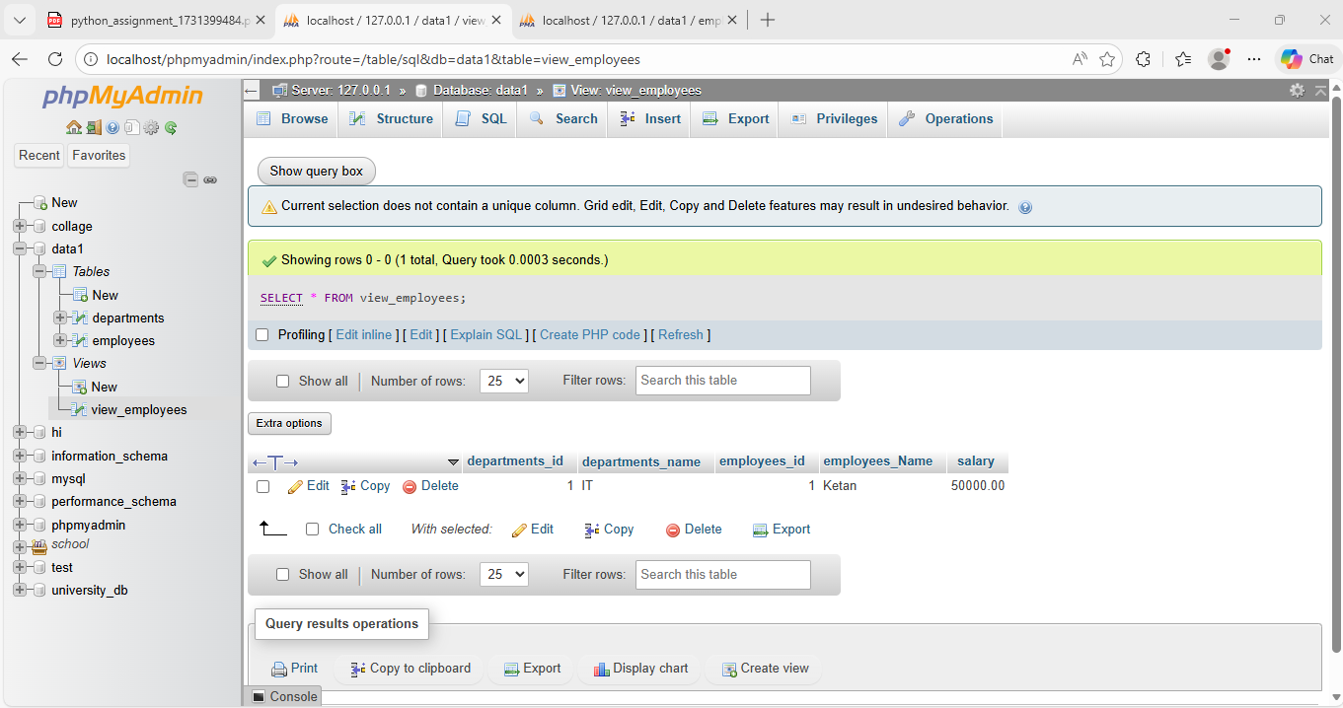

1. **SQL Triggers**

**Lab 1: Create a trigger to automatically log changes to the employees table when a new employee is added.**

**Lab 2: Create a trigger to update the last_modified timestamp whenever an employee record is updated.**

**EXTRA LAB PRACTISE FOR DATABASE CONCEPTS**

1. **Introduction to SQL**

**Lab 3: Create a database called library_db and a table books with columns: book_id, title, author, publisher, year_of_publication, and price. Insert five records into the table.**

**CREATE DATABASE library_db;**

**CREATE TABLE books(book_id INT(10) PRIMARY KEY AUTO_INCREMENT,title VARCHAR(50),author VARCHAR(50),publisher VARCHAR(50),year_of_publication DATE,price DECIMAL(10.2));**

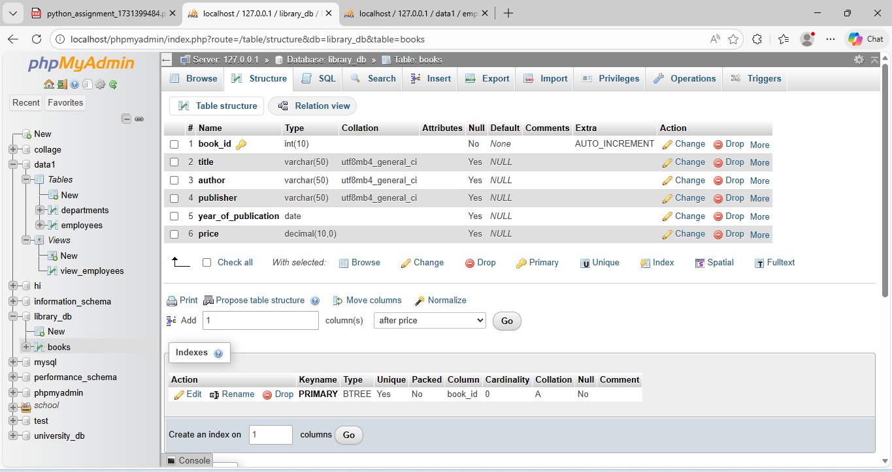

**• Lab 4: Create a table members in library_db with columns: member_id, member_name, date_of_membership, and email. Insert five records into this table.**

**CREATE TABLE members(member_id INT(10) PRIMARY KEY AUTO_INCREMENT,member_name VARCHAR(50),date_of_membership DATE,email VARCHAR(50));**

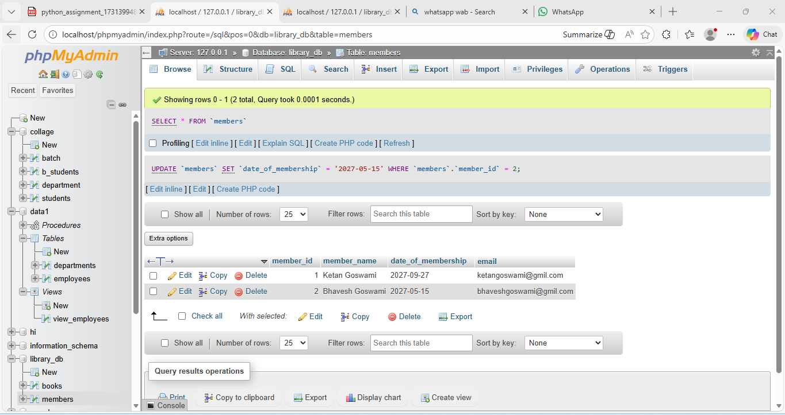

1. **SQL Syntax**

**Lab 3: Retrieve all members who joined the library before 2022. Use appropriate SQL syntax with WHERE and ORDER BY.**

**SELECT * FROM members WHERE date_of_membership < '2022-01-01' ORDER BY date_of_membership;**

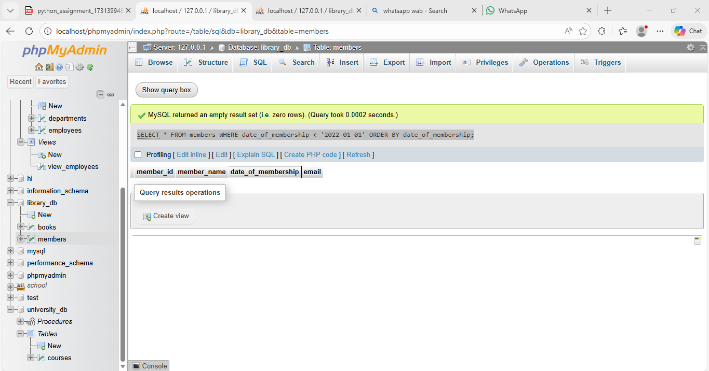

**Lab 4: Write SQL queries to display the titles of books published by a specific author. Sort the results by year_of_publication in descending order.**

**SELECT title FROM books WHERE author = 'Joshua Bloch'**

**ORDER BY year_of_publication;**

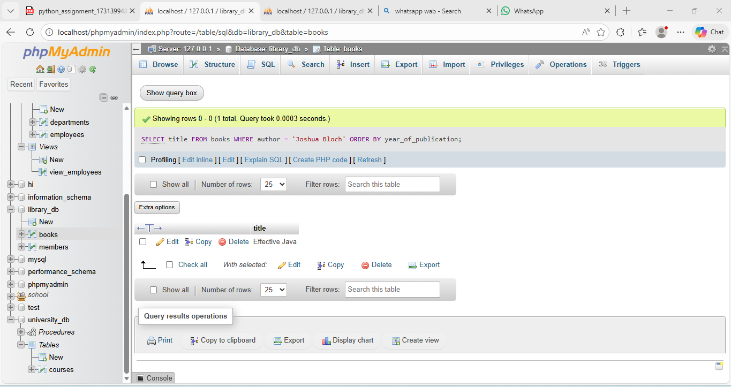

1. **SQL Constraints**

**Lab 3: Add a CHECK constraint to ensure that the price of books in the books table is greater than 0.**

**ALTER TABLE books ADD CONSTRAINT chk_price_positive CHECK (price > 0);**

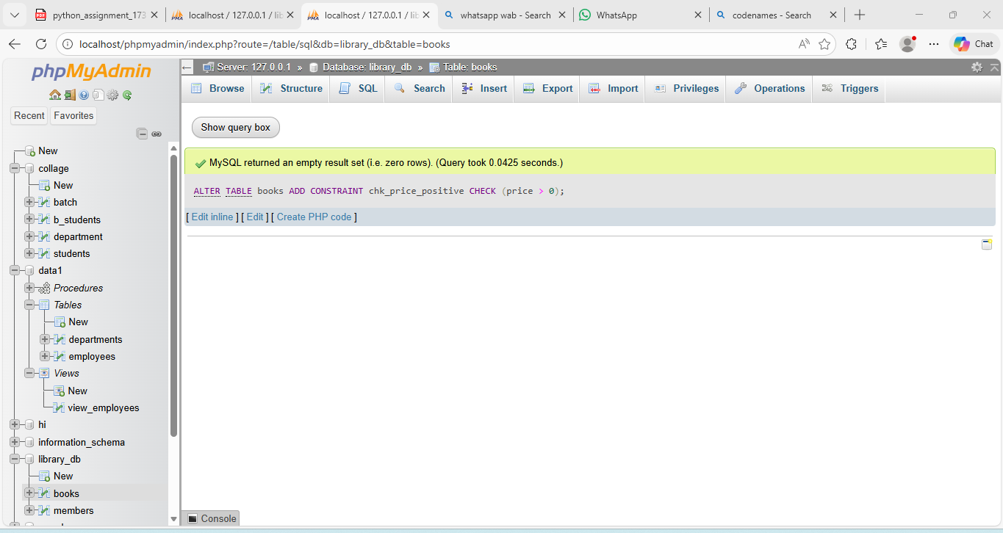

**Lab 4: Modify the members table to add a UNIQUE constraint on the email column,**

**ensuring that each member has a unique email address.**

**ALTER TABLE members ADD CONSTRAINT unique_email UNIQUE (email);**

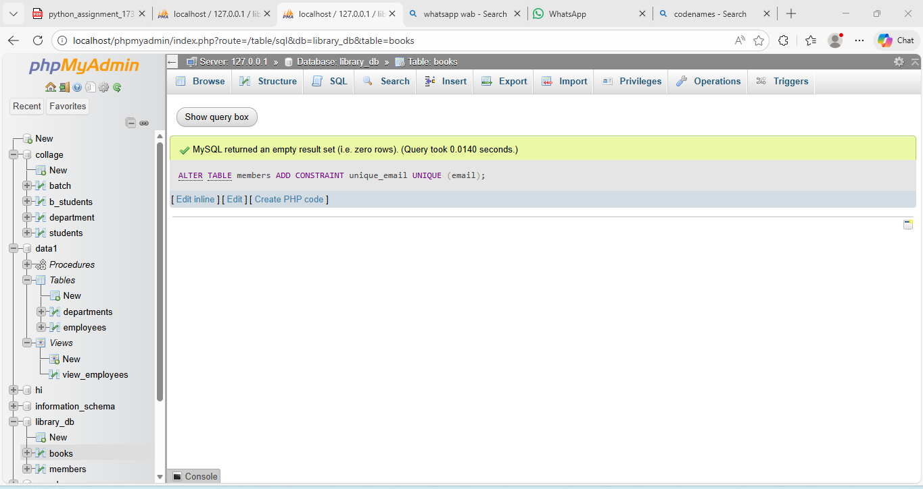

1. **Main SQL Commands and Sub-commands (DDL)**

**Lab 3: Create a table authors with the following columns: author_id, first_name,**

**last_name, and country. Set author_id as the primary key.**

**CREATE TABLE authors ( author_id INT AUTO_INCREMENT PRIMARY KEY, first_name VARCHAR(50) NOT NULL, last_name VARCHAR(50) NOT NULL, country VARCHAR(50) );**

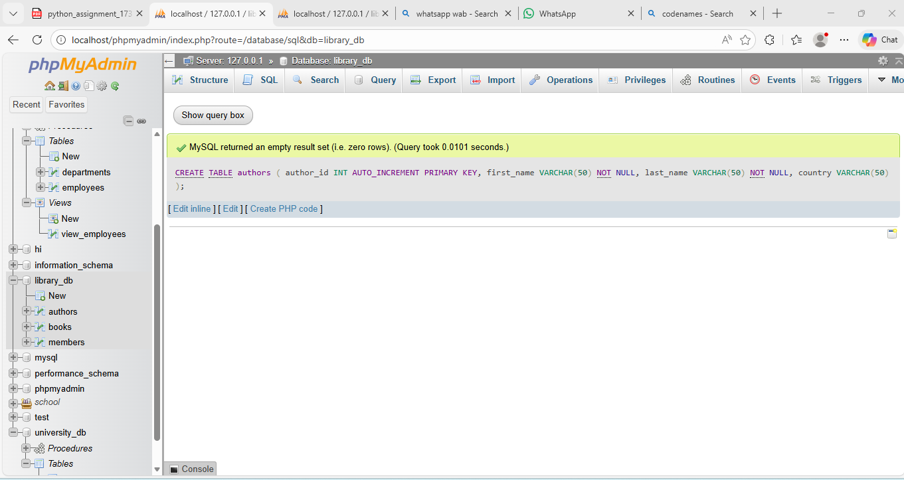

**Lab 4: Create a table publishers with columns: publisher_id, publisher_name,**

**contact_number, and address. Set publisher_id as the primary key and**

**contact_number as unique.**

**CREATE TABLE publishers ( publisher_id INT AUTO_INCREMENT PRIMARY KEY, publisher_name VARCHAR(100) NOT NULL, contact_number VARCHAR(20) UNIQUE, address VARCHAR(150) );**

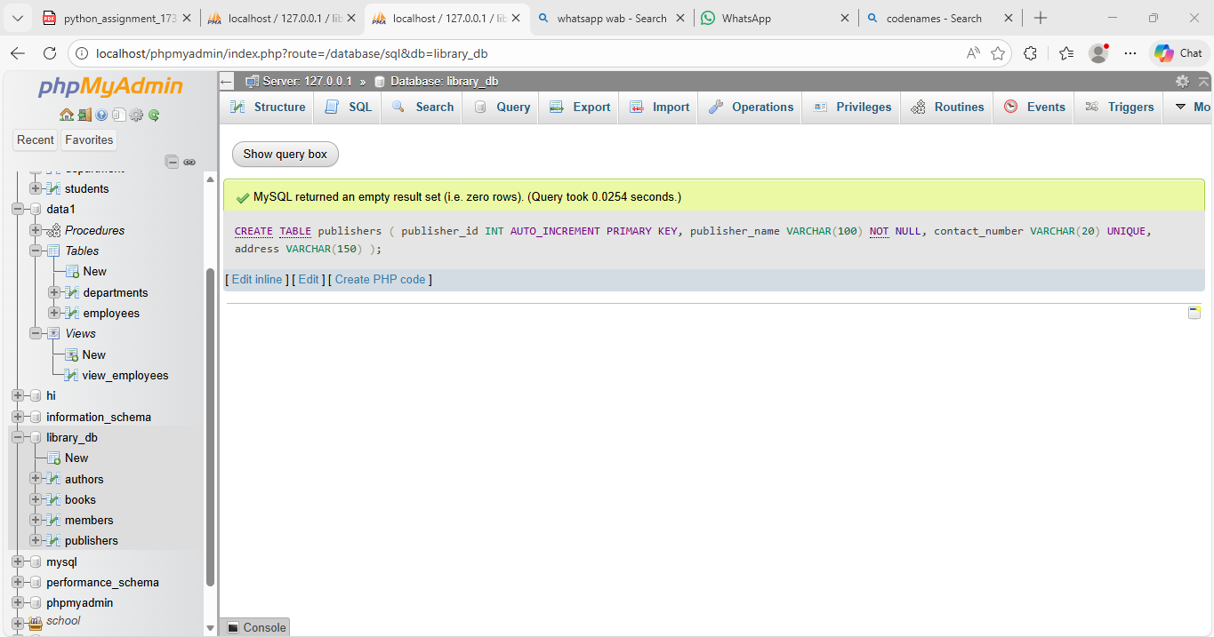

1. **ALTER Command**

**Lab 3: Add a new column genre to the books table. Update the genre for all existing**

**records.**

**ALTER TABLE books ADD COLUMN genre VARCHAR(50);**

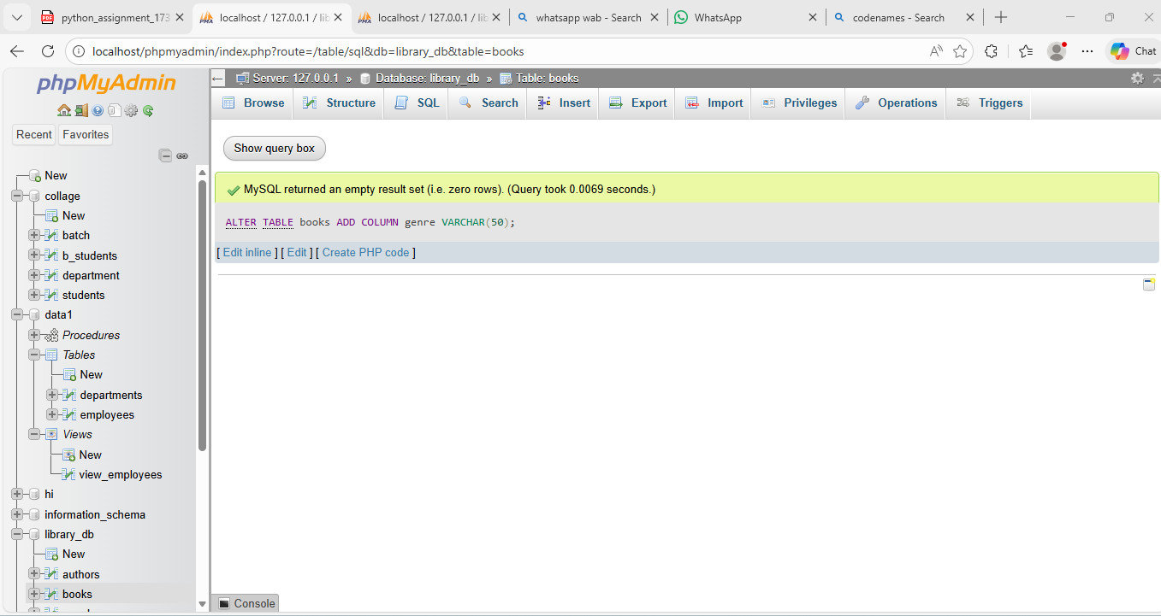

**Lab 4: Modify the members table to increase the length of the email column to 100 characters.**

**ALTER TABLE books MODIFY COLUMN genre VARCHAR(50) DEFAULT 'Available';**

1. **DROP Command**

**Lab 3: Drop the publishers table from the database after verifying its structure.**

**DROP TABLE publishers;**

**Lab 4: Create a backup of the members table and then drop the original members table.**

**CREATE TABLE members_backup AS SELECT * FROM members;**

**DROP TABLE members;**

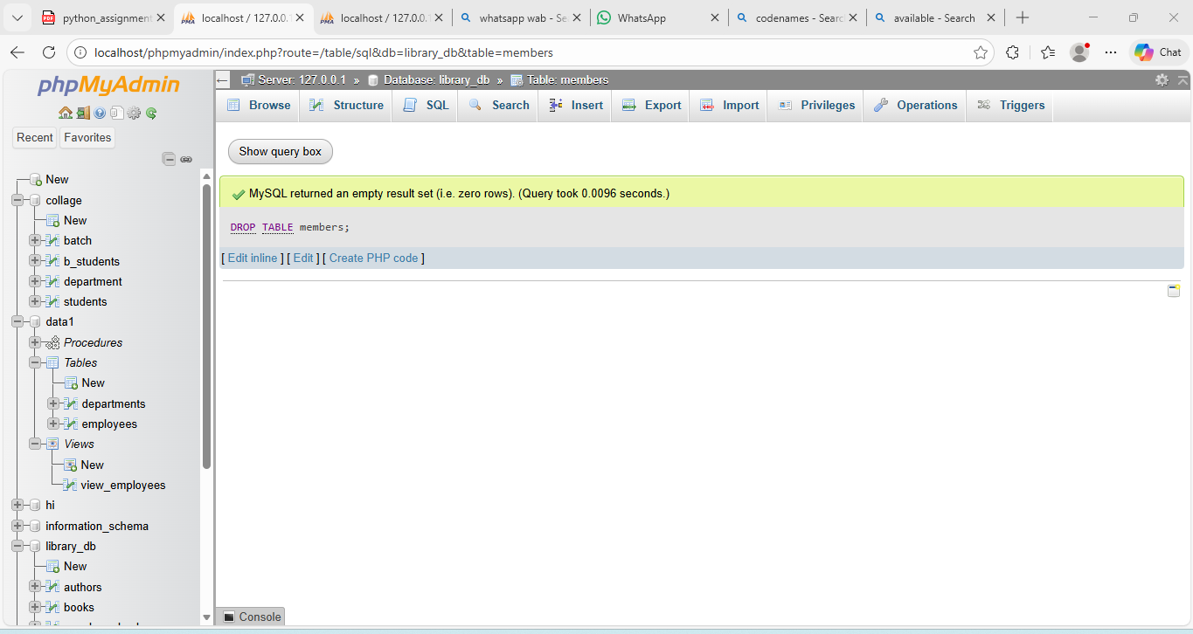

1. **Data Manipulation Language (DML)**

**Lab 4: Insert three new authors into the authors table, then update the last name of one of the authors.**

**INSERT INTO authors (first_name, last_name, country) VALUES ('Chetan', 'Bhagat', 'India'), ('Ruskin', 'Bond', 'India'), ('Amish', 'Tripathi', 'India');**

**UPDATE authors SET last_name = 'T' WHERE first_name = 'Amish' AND last_name = 'Tripathi';**

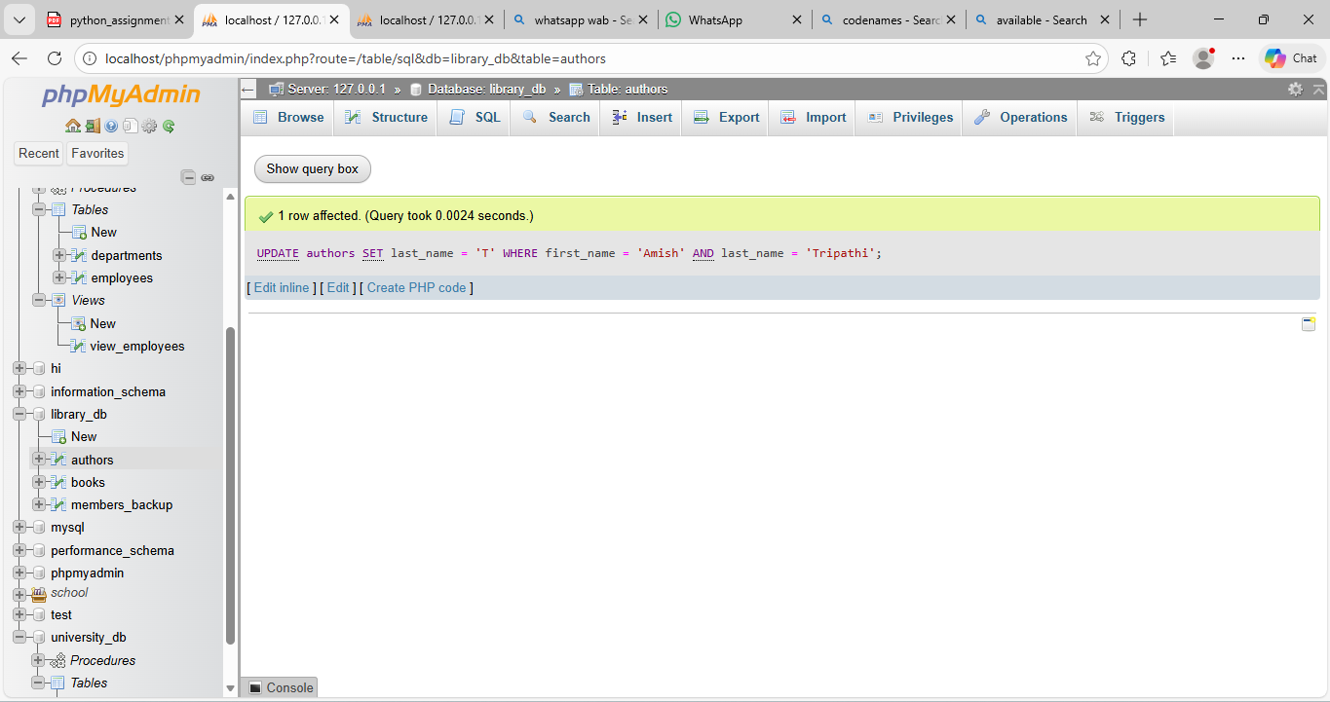

**Lab 5: Delete a book from the books table where the price is higher than $100.**

**DELETE FROM books WHERE price > 100;**

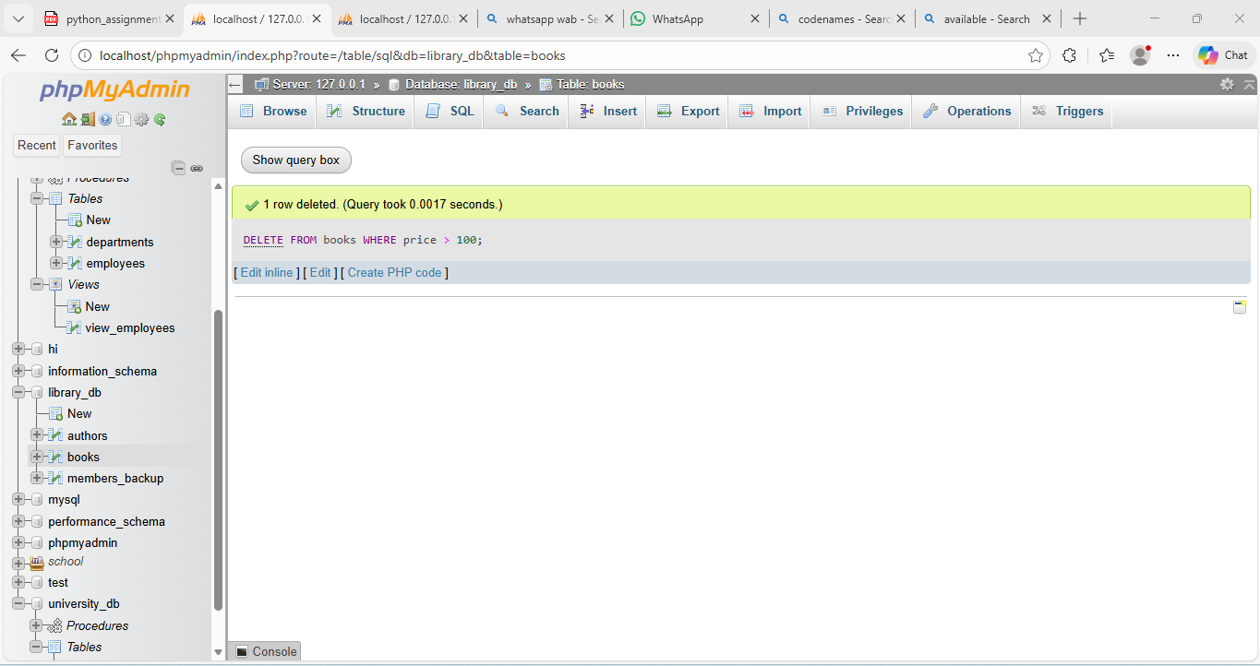

1. **UPDATE Command**